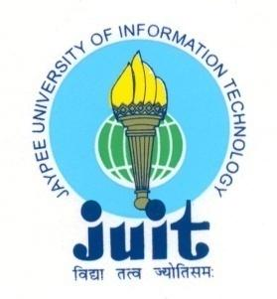 | JAYPEE UNIVERSITY OF INFORMATION TECHNOLOGY  (Established by H.P.State Legislative vide Act No. 14 of 2002)  Waknaghat, P.O. Dumehar Bani, Kandaghat, Distt. Solan – 173234 (H.P.) INDIA  Website :www.juit.ac.in  Phone No. (91) 01792-257999 (30 Lines)  Fax : (91) 01792 245362
SUMMARY SHEET

Criteria | Criterion 1 – Curricular Aspects
Key Indicator | 1.1. Curriculum Design and Development
Metric | 1.1.3. Average percentage of courses having focus on employability/ entrepreneurship/ skill development during the last five years
Response | 1.1.3.1: Number of courses having focus on employability/ entrepreneurship/ skill development year wise during the last five years  Year 2017-2018 2018-2019 2019-2020 2020-2021 2021-2022  Number 95 228 238 291 319

Syllabus copy of the courses which focuses on employability/ entrepreneurship/ skill development are highlighted in Green Color.

Note: The supporting documents for this metric exceed the upload limit of 5Mb. Hence, the links for sample documents are given below. If required, all/any supporting documents will be provided.

Sr. No. | Description | Relevant link
1 | Syllabus 2017-18 | https://www.juit.ac.in/NAAC2022/NAACFILES/1/1.1/1.1.3/Syllabii_of_the_courses_of_last_five_years/2017-18.pdf
2 | Syllabus 2018-19 | https://www.juit.ac.in/NAAC2022/NAACFILES/1/1.1/1.1.3/Syllabii_of_the_courses_of_last_five_years/2018-19.pdf
3 | Syllabus 2019-20 | https://www.juit.ac.in/NAAC2022/NAACFILES/1/1.1/1.1.3/Syllabii_of_the_courses_of_last_five_years/2019-20.pdf
4 | Syllabus 2020-21 | https://www.juit.ac.in/NAAC2022/NAACFILES/1/1.1/1.1.3/Syllabii_of_the_courses_of_last_five_years/2020-21.pdf
5 | Syllabus 2021-22 | https://www.juit.ac.in/NAAC2022/NAACFILES/1/1.1/1.1.3/Syllabii_of_the_courses_of_last_five_years/2021-22.pdf

