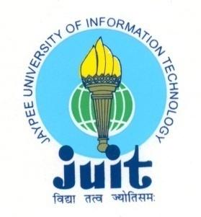 | JAYPEE UNIVERSITY OF INFORMATION TECHNOLOGY  (Established by H.P.State Legislative vide Act No. 14 of 2002)  Waknaghat, P.O. Dumehar Bani, Kandaghat, Distt. Solan – 173234 (H.P.) INDIA  Website :www.juit.ac.in  Phone No. (91) 01792-257999 (30 Lines)  Fax : (91) 01792 245362
SUMMARY SHEET

Criteria | Criterion 1 – Curricular Aspects
Key Indicator | 1.1. Curriculum Design and Development
Metric | 1.1.3. Average percentage of courses having focus on employability/ entrepreneurship/ skill development during the last five years

Link of MoU's with relevant organizations:

Sr. No. | Description | Relevant link
1 | Misubishi Electric India Pvt Ltd.pdf | https://www.juit.ac.in/NAAC2022/NAACFILES/1/?dir=1.1%2F1.1.3
2 | NHAI | https://www.juit.ac.in/NAAC2022/NAACFILES/1/?dir=1.1%2F1.1.3

