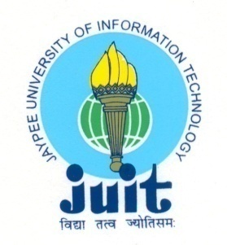 | JAYPEE UNIVERSITY OF INFORMATION TECHNOLOGY  (Established by H.P.State Legislative vide Act No. 14 of 2002)  Waknaghat, P.O. Dumehar Bani, Kandaghat, Distt. Solan – 173234 (H.P.) INDIA  Website :www.juit.ac.in  Phone No. (91) 01792-257999 (30 Lines)  Fax : (91) 01792 245362

Criteria | Criterion 1 - Curricular Aspects
Key Indicator | 1.1 Curriculum Design and Development
Metrics | 1.1.1:- Curricula developed and implemented have relevance to the local, national, regional and global developmental needs, which is reflected in the Programme outcomes (POs), Programme Specific Outcomes(PSOs) and Course Outcomes(COs) of the Programmes offered by the University Write description in a maximum of 500 words

Programme outcomes (POs), Programme Specific Outcomes(PSOs) and Course Outcomes(COs) of the various departments
Programme Code | Programme Name | PO CO Document
BTECE | B.Tech Electronics & Communication Engineering | https://www.juit.ac.in/electronic-communication-engineering
BTCS | B.Tech Computer Science & Engineering | https://www.juit.ac.in/computer-science-engineering-information-technology
BTIT | B.Tech Information Technology | https://www.juit.ac.in/computer-science-engineering-information-technology
BTCE | B.Tech Civil Engineering | https://www.juit.ac.in/civil-engineering
BTBT | B.Tech Biotechnology | https://www.juit.ac.in/biotechnology-bioinformatics
BTBI | B.Tech Bioinformatics | https://www.juit.ac.in/biotechnology-bioinformatics

CO-PO mapping for 2021-22 :

https://www.juit.ac.in/NAAC2022/NAACFILES/1/1.1/1.1.1/1.1.1.pdf

